Ammar Ahmed 20L-0961 Section: BDS-2B
Code Snippets

Question 1, with hardcoded input
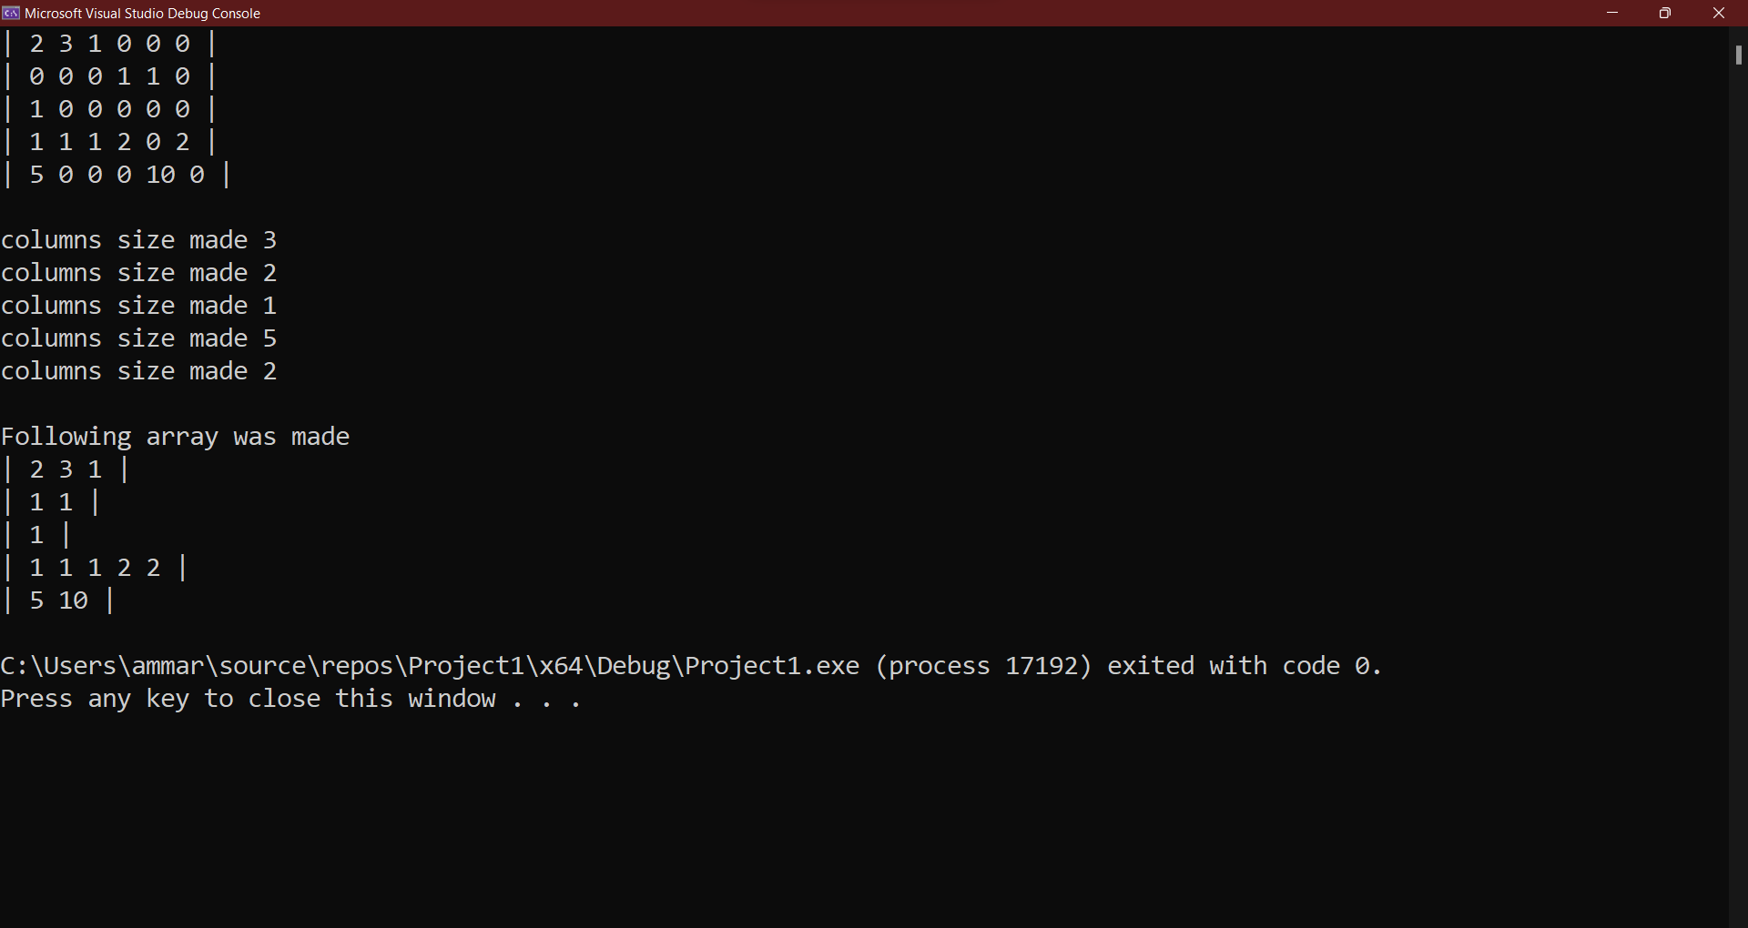
Question 1, with custom input
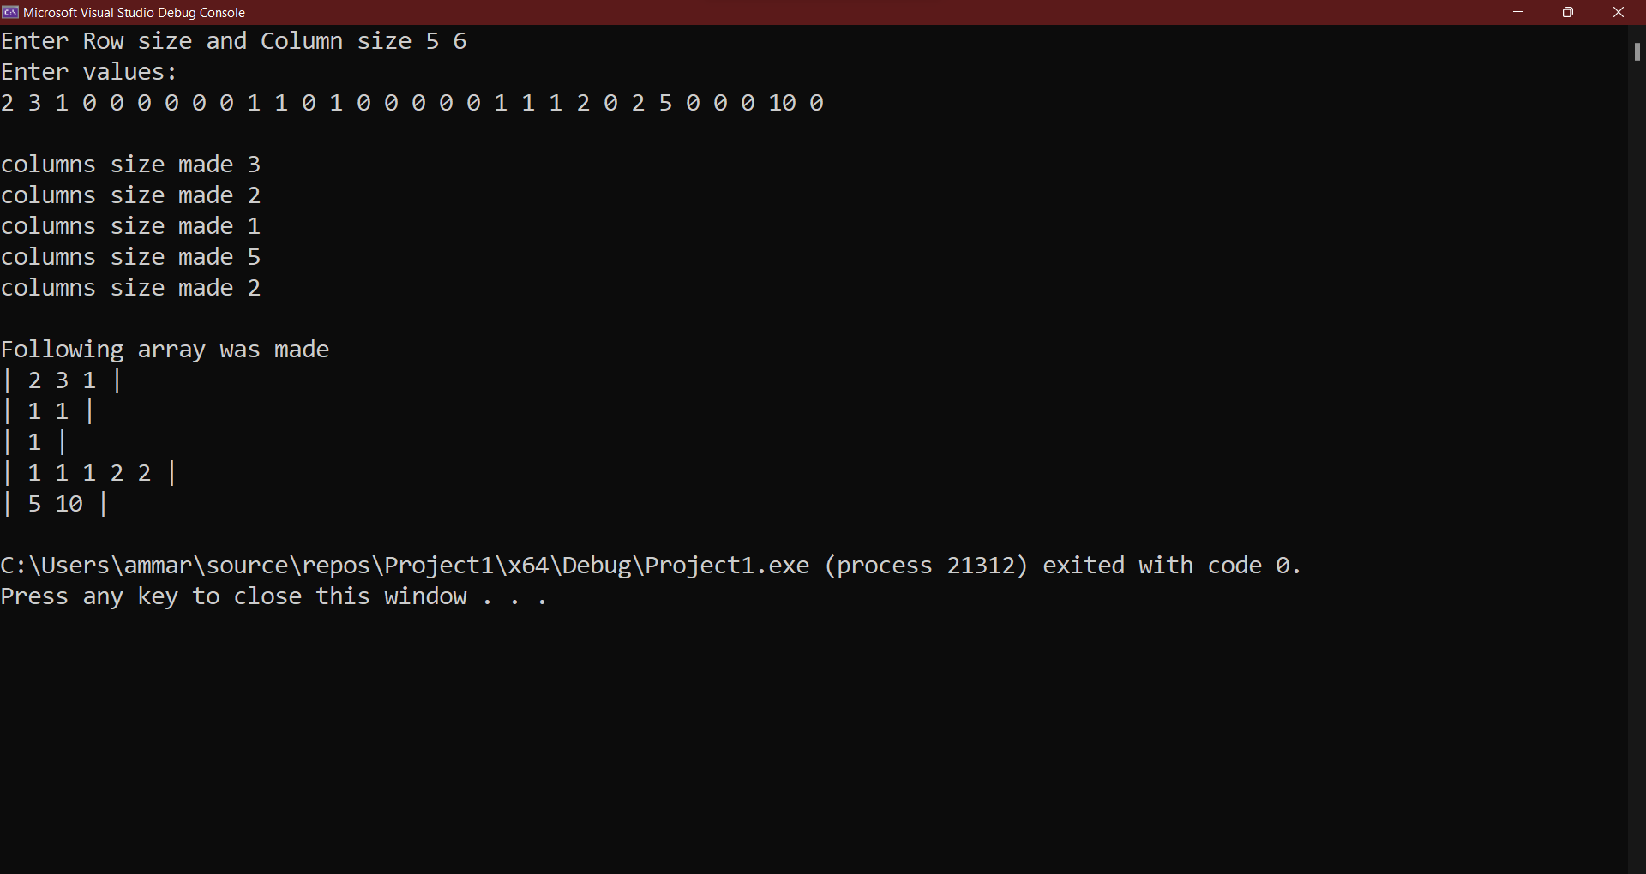

Question 2, with input from question
